Prisms

Definition
# Source: AI Source: Provided by: [Data Path: Persons Table -> ID Column: 1, Name_En Column: Motasem Essam] -> From: [ChatGPT] on [7/25/2026]
A prism is a polyhedron with two congruent, parallel polygonal faces called bases, connected by parallelogram-shaped lateral faces.
In a right prism, the lateral faces are rectangles, and the lateral edges are perpendicular to the bases. In an oblique prism, the lateral edges are inclined to the bases.
Prisms are classified according to the shape of their polygonal bases, such as triangular prisms, rectangular prisms, pentagonal prisms, and hexagonal prisms.
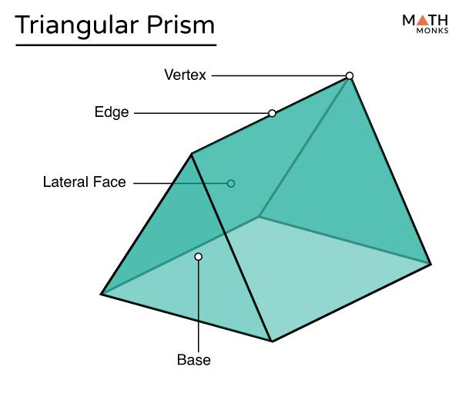
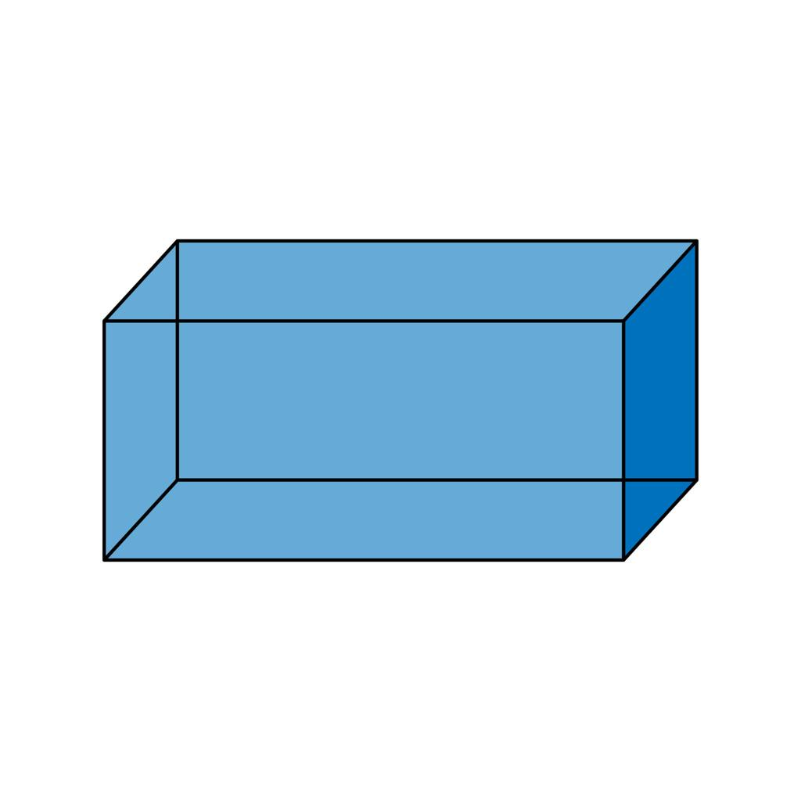
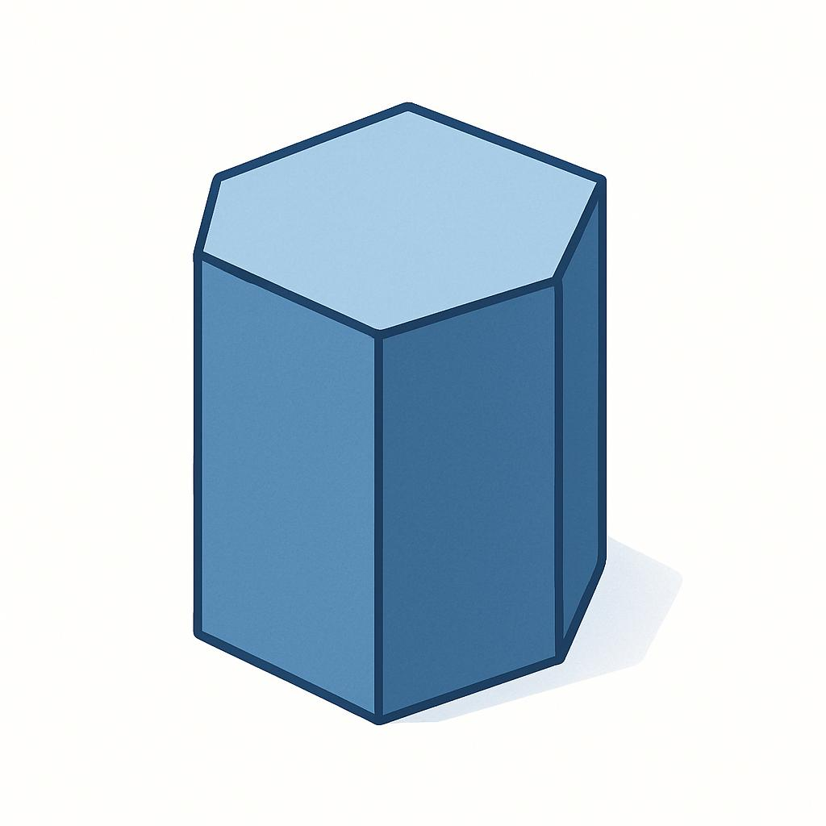

Simple definition
# Source: AI Source: Provided by: [Data Path: Persons Table -> ID Column: 1, Name_En Column: Motasem Essam] -> From: [ChatGPT] on [7/25/2026]
A prism is a 3D shape with two identical polygonal ends that are parallel to each other and joined by side faces.
Examples include:
- A triangular prism has two triangular bases.
- A rectangular prism has two rectangular bases.
- A pentagonal prism has two pentagonal bases.
- A hexagonal prism has two hexagonal bases.
The polygon used for the base determines the name of the prism.

Classification tree
# Source: AI Source: Provided by: [Data Path: Persons Table -> ID Column: 1, Name_En Column: Motasem Essam] -> From: [ChatGPT] on [7/25/2026]
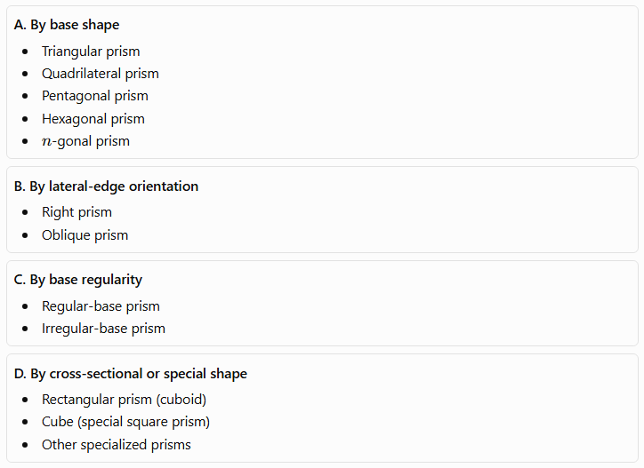
A. By base shape
- Triangular prism
- Quadrilateral prism
- Pentagonal prism
- Hexagonal prism
- $n$-gonal prism
B. By lateral-edge orientation
- Right prism
- Oblique prism
C. By base regularity
- Regular-base prism
- Irregular-base prism
D. By cross-sectional or special shape
- Rectangular prism (cuboid)
- Cube (special square prism)
- Other specialized prisms
These classifications describe different properties, so one prism can belong to several categories at the same time. For example, a right regular hexagonal prism has regular hexagonal bases and perpendicular lateral edges.

Main types of prisms

1. Triangular prism
# Source: AI Source: Provided by: [Data Path: Persons Table -> ID Column: 1, Name_En Column: Motasem Essam] -> From: [ChatGPT] on [7/25/2026]
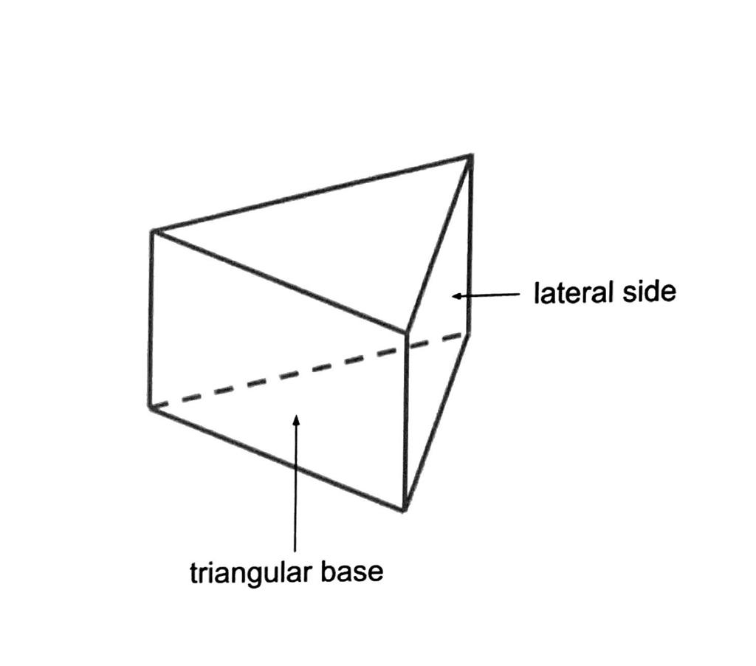
A triangular prism has two congruent, parallel triangular bases connected by three lateral faces.
- Faces: 5
- Edges: 9
- Vertices: 6
A triangular prism can have equilateral, isosceles, or scalene triangular bases. Its lateral faces are rectangles when it is a right prism and parallelograms when it is oblique.

2. Quadrilateral prism
# Source: AI Source: Provided by: [Data Path: Persons Table -> ID Column: 1, Name_En Column: Motasem Essam] -> From: [ChatGPT] on [7/25/2026]
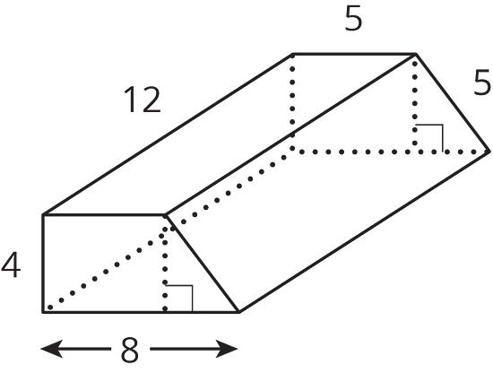
A quadrilateral prism has two congruent, parallel four-sided polygonal bases.
- Faces: 6
- Edges: 12
- Vertices: 8
The bases may be squares, rectangles, parallelograms, trapezoids, or other quadrilaterals. A rectangular prism, also called a cuboid, is a common special case.

3. Pentagonal prism
# Source: AI Source: Provided by: [Data Path: Persons Table -> ID Column: 1, Name_En Column: Motasem Essam] -> From: [ChatGPT] on [7/25/2026]
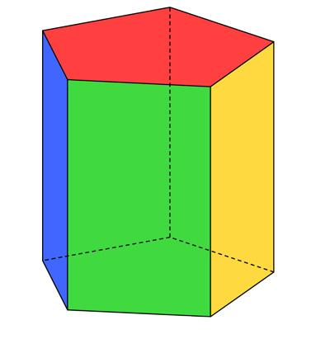
A pentagonal prism has two congruent pentagonal bases joined by five lateral faces.
- Faces: 7
- Edges: 15
- Vertices: 10
If its bases are regular pentagons and it is a right prism, it is a regular pentagonal prism.

4. Hexagonal prism
# Source: AI Source: Provided by: [Data Path: Persons Table -> ID Column: 1, Name_En Column: Motasem Essam] -> From: [ChatGPT] on [7/25/2026]
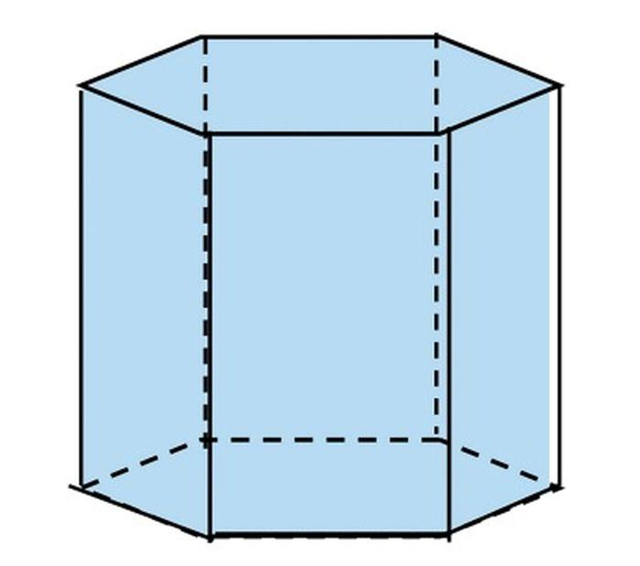
A hexagonal prism has two congruent hexagonal bases joined by six lateral faces.
- Faces: 8
- Edges: 18
- Vertices: 12
Hexagonal prisms are used in geometric models and resemble the shape of some nuts, columns, and structural components.

5. Rectangular prism (cuboid)
# Source: AI Source: Provided by: [Data Path: Persons Table -> ID Column: 1, Name_En Column: Motasem Essam] -> From: [ChatGPT] on [7/25/2026]
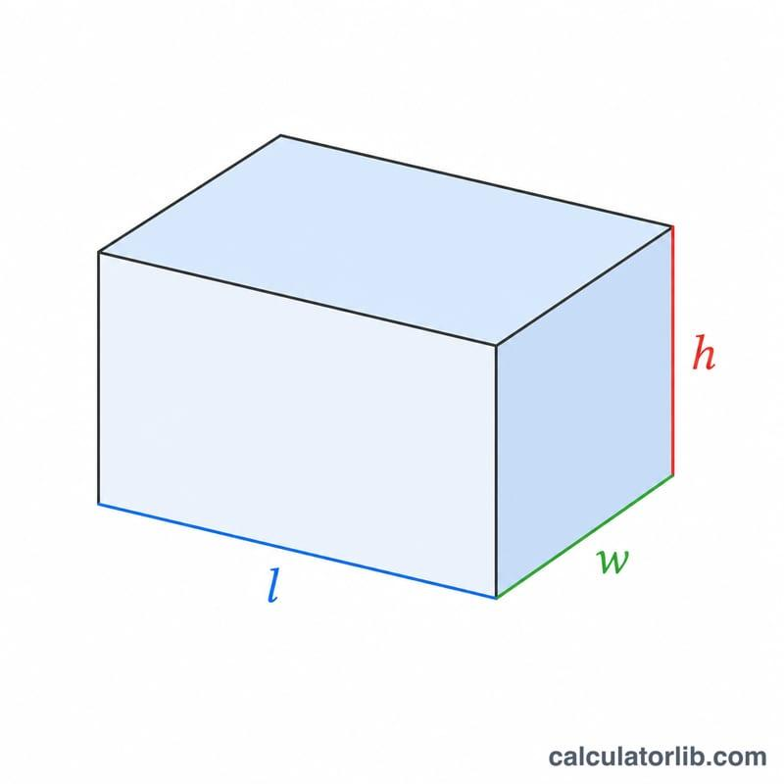
A rectangular prism, or cuboid, is a prism with rectangular faces.
- Faces: 6 rectangles
- Edges: 12
- Vertices: 8
A cuboid has length $l$, width $w$, and height $h$. A box or brick is a familiar example.

6. Cube
# Source: AI Source: Provided by: [Data Path: Persons Table -> ID Column: 1, Name_En Column: Motasem Essam] -> From: [ChatGPT] on [7/25/2026]
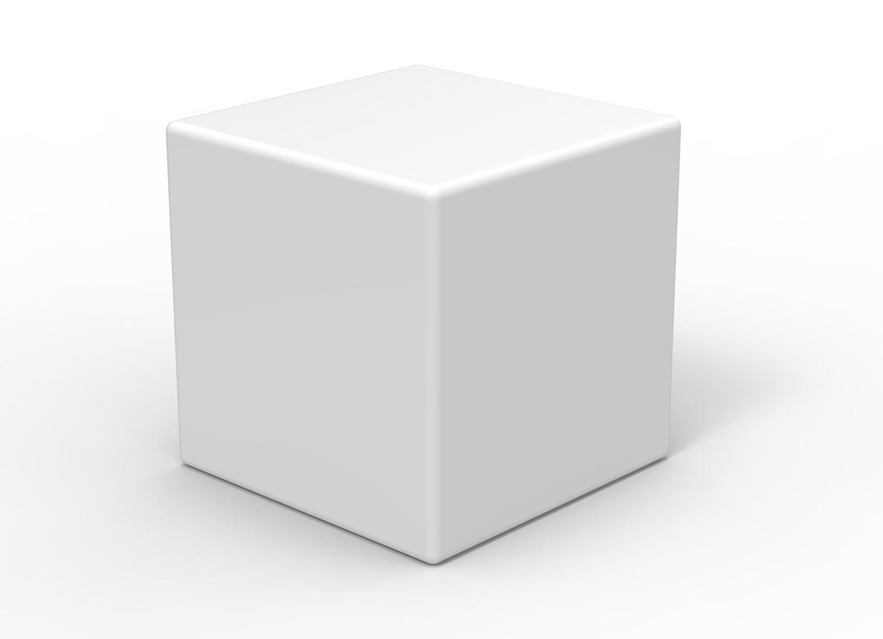
A cube is a special rectangular prism whose six faces are equal squares and whose twelve edges have equal lengths.
- Faces: 6 squares
- Edges: 12 equal edges
- Vertices: 8
A cube can be regarded as a right square prism, with the two opposite square faces serving as its bases.

7. $n$-gonal prism
# Source: AI Source: Provided by: [Data Path: Persons Table -> ID Column: 1, Name_En Column: Motasem Essam] -> From: [ChatGPT] on [7/25/2026]
An $n$-gonal prism is a prism whose bases are congruent $n$-sided polygons.
Examples:
- $n=3$: triangular prism
- $n=4$: quadrilateral prism
- $n=5$: pentagonal prism
- $n=6$: hexagonal prism
- $n=8$: octagonal prism
For an $n$-gonal prism:
$$\boxed{F=n+2}$$
$$\boxed{E=3n}$$
$$\boxed{V=2n}$$
Here, $F$ is the number of faces, $E$ is the number of edges, and $V$ is the number of vertices.

Right prisms and oblique prisms

Right prism
# Source: AI Source: Provided by: [Data Path: Persons Table -> ID Column: 1, Name_En Column: Motasem Essam] -> From: [ChatGPT] on [7/25/2026]
The lateral edges are perpendicular to the bases. The lateral faces are rectangles.
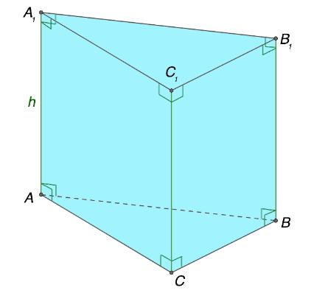

Oblique prism
# Source: AI Source: Provided by: [Data Path: Persons Table -> ID Column: 1, Name_En Column: Motasem Essam] -> From: [ChatGPT] on [7/25/2026]
The lateral edges are inclined to the bases. The lateral faces are parallelograms.
Both types have congruent, parallel bases. The key difference is the orientation of the lateral edges.
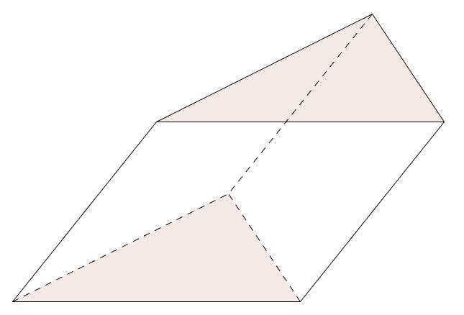

Key characteristics of prisms
# Source: AI Source: Provided by: [Data Path: Persons Table -> ID Column: 1, Name_En Column: Motasem Essam] -> From: [ChatGPT] on [7/25/2026]
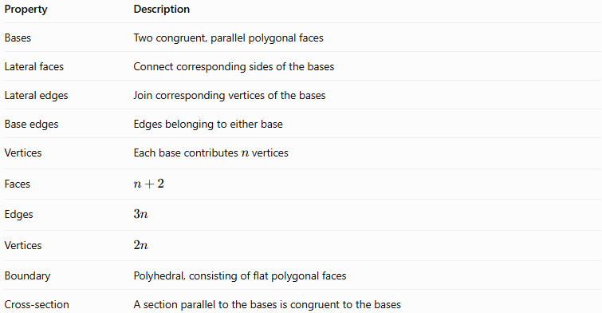
Property | Description
Bases | Two congruent, parallel polygonal faces
Lateral faces | Connect corresponding sides of the bases
Lateral edges | Join corresponding vertices of the bases
Base edges | Edges belonging to either base
Vertices | Each base contributes $n$ vertices
Faces | $$n+2$$
Edges | $$3n$$
Vertices | $$2n$$
Boundary | Polyhedral, consisting of flat polygonal faces
Cross-section | A section parallel to the bases is congruent to the bases
The cross-section property applies to a prism throughout its height: every cross-section made by a plane parallel to the bases has the same shape and size as a base.

Mathematical formulas for prisms
# Source: AI Source: Provided by: [Data Path: Persons Table -> ID Column: 1, Name_En Column: Motasem Essam] -> From: [ChatGPT] on [7/25/2026]
Let:
- $B$ = area of one base
- $p$ = perimeter of one base
- $h$ = perpendicular distance between the bases
- $n$ = number of sides of the base polygon

1. Volume
# Source: AI Source: Provided by: [Data Path: Persons Table -> ID Column: 1, Name_En Column: Motasem Essam] -> From: [ChatGPT] on [7/25/2026]
The volume of any prism is:
$$\boxed{V=Bh}$$
This formula works for both right and oblique prisms, provided $h$ is the perpendicular distance between the bases.

2. Lateral surface area
# Source: AI Source: Provided by: [Data Path: Persons Table -> ID Column: 1, Name_En Column: Motasem Essam] -> From: [ChatGPT] on [7/25/2026]
For a right prism, the lateral surface area is:
$$\boxed{S_{L}=ph}$$
This is the perimeter of the base multiplied by the height.
For an oblique prism, the lateral faces are generally parallelograms, so their individual areas must be calculated and added.

3. Total surface area
# Source: AI Source: Provided by: [Data Path: Persons Table -> ID Column: 1, Name_En Column: Motasem Essam] -> From: [ChatGPT] on [7/25/2026]
For a right prism:
$$\boxed{S_{T}=ph+2B}$$
The formula adds the lateral surface area to the areas of the two bases.

4. Euler's formula
# Source: AI Source: Provided by: [Data Path: Persons Table -> ID Column: 1, Name_En Column: Motasem Essam] -> From: [ChatGPT] on [7/25/2026]
Every convex prism satisfies Euler's polyhedron formula:
$$V-E+F=2$$
Substituting the counts for an $n$-gonal prism:
$$2n-3n+\left(n+2\right)=2$$
Therefore, the general prism counts agree with Euler's formula.

Worked examples
# Source: AI Source: Provided by: [Data Path: Persons Table -> ID Column: 1, Name_En Column: Motasem Essam] -> From: [ChatGPT] on [7/25/2026]
Example 1: Number of faces, edges, and vertices
A hexagonal prism has a hexagonal base, so $n=6$.
Number of faces:
$$F=n+2=6+2=\boxed{8}$$
Number of edges:
$$E=3n=3\left(6\right)=\boxed{18}$$
Number of vertices:
$$V=2n=2\left(6\right)=\boxed{12}$$
Check Euler's formula:
$$12-18+8=\boxed{2}$$
Example 2: Volume of a triangular prism
A triangular prism has a triangular base with area $B=15{\text{ cm}}^{2}$ and perpendicular height $h=10\text{ cm}$.
$$V=Bh$$
$$V=15×10$$
$$\boxed{V=150{\text{ cm}}^{3}}$$
Example 3: Total surface area of a right prism
A right triangular prism has a triangular base with side lengths $3\text{ cm}$, $4\text{ cm}$, and $5\text{ cm}$. The prism height is $8\text{ cm}$.
First, calculate the base area. Since the triangle is right-angled:
$$B=\frac{12}{\left(3\right)}\left(4\right)=6{\text{ cm}}^{2}$$
Next, calculate its perimeter:
$$p=3+4+5=12\text{ cm}$$
Lateral surface area:
$$S_{L}=ph=12\left(8\right)=96{\text{ cm}}^{2}$$
Total surface area:
$$S_{T}=S_{L}+2B$$
$$S_{T}=96+2\left(6\right)$$
$$\boxed{S_{T}=108{\text{ cm}}^{2}}$$

Constructing Prisms in Solid Geometry

Geometric Instruments Used
# Source: AI Source: Provided by: [Data Path: Persons Table -> ID Column: 1, Name_En Column: Motasem Essam] -> From: [ChatGPT] on [7/25/2026]
The construction of prisms can use the following geometric instruments:
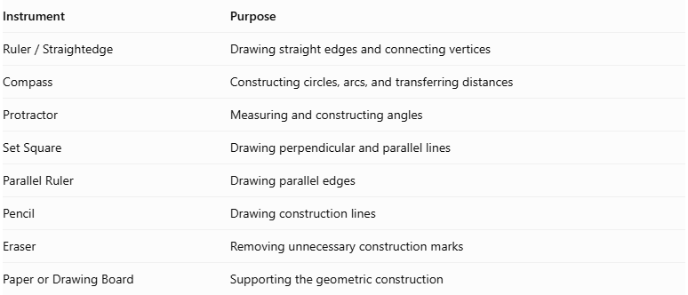
Instrument | Purpose
$$Ruler/Straightedge$$ | Drawing straight edges and connecting vertices
Compass | Constructing circles, arcs, and transferring distances
Protractor | Measuring and constructing angles
Set Square | Drawing perpendicular and parallel lines
Parallel Ruler | Drawing parallel edges
Pencil | Drawing construction lines
Eraser | Removing unnecessary construction marks
Paper or Drawing Board | Supporting the geometric construction

Instrument-Based Construction Procedures

Constructing the Base Polygon
# Source: AI Source: Provided by: [Data Path: Persons Table -> ID Column: 1, Name_En Column: Motasem Essam] -> From: [ChatGPT] on [7/25/2026]
- Select the polygon that will form the prism's bases.
- Use a ruler, compass, and protractor as appropriate to construct the polygon.
- Mark its vertices and edges.
- Ensure that the polygon has the required dimensions and angles.

Constructing the Second Base
# Source: AI Source: Provided by: [Data Path: Persons Table -> ID Column: 1, Name_En Column: Motasem Essam] -> From: [ChatGPT] on [7/25/2026]
- Construct a second polygon congruent to the first.
- Position it separately from the first polygon.
- Ensure that the two bases are parallel.
- Match corresponding vertices and sides.

Connecting Corresponding Vertices
# Source: AI Source: Provided by: [Data Path: Persons Table -> ID Column: 1, Name_En Column: Motasem Essam] -> From: [ChatGPT] on [7/25/2026]
- Identify each vertex on the first base.
- Connect it to its corresponding vertex on the second base.
- Keep all lateral edges parallel and equal in length.
- Ensure that the resulting lateral faces are parallelograms.

Completing the Prism
# Source: AI Source: Provided by: [Data Path: Persons Table -> ID Column: 1, Name_En Column: Motasem Essam] -> From: [ChatGPT] on [7/25/2026]
- Draw all visible edges.
- Use dashed lines for hidden edges when necessary.
- Check that both bases are congruent and parallel.
- Verify that all corresponding vertices are correctly connected.

Constructing a Right Prism
# Source: AI Source: Provided by: [Data Path: Persons Table -> ID Column: 1, Name_En Column: Motasem Essam] -> From: [ChatGPT] on [7/25/2026]
- Construct the first polygonal base.
- Draw perpendicular lateral edges from its vertices.
- Make the lateral edges equal in length.
- Construct the second base by connecting their endpoints.
- Complete the lateral rectangular faces.

Constructing an Oblique Prism
# Source: AI Source: Provided by: [Data Path: Persons Table -> ID Column: 1, Name_En Column: Motasem Essam] -> From: [ChatGPT] on [7/25/2026]
- Construct the first polygonal base.
- Draw inclined lateral edges from its vertices.
- Keep all lateral edges parallel and equal in length.
- Construct the second base by connecting their endpoints.
- Complete the lateral parallelogram faces.

Constructing a Prism Using a Net
# Source: AI Source: Provided by: [Data Path: Persons Table -> ID Column: 1, Name_En Column: Motasem Essam] -> From: [ChatGPT] on [7/25/2026]
- Draw two congruent polygonal bases.
- Draw the required lateral faces as connected parallelograms.
- Ensure that their dimensions match the corresponding base edges and lateral edges.
- Arrange the faces so that they can be folded and joined correctly.
- Fold the net and connect the matching edges to form the prism.

Comparison with other polyhedral
# Source: AI Source: Provided by: [Data Path: Persons Table -> ID Column: 1, Name_En Column: Motasem Essam] -> From: [ChatGPT] on [7/25/2026]
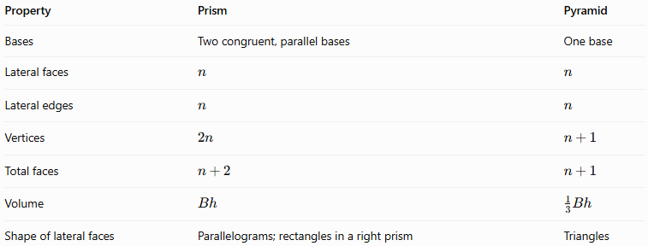
Property | Prism | Pyramid
Bases | Two congruent, parallel bases | One base
Lateral faces | $$n$$ | $$n$$
Lateral edges | $$n$$ | $$n$$
Vertices | $$2n$$ | $$n+1$$
Total faces | $$n+2$$ | $$n+1$$
Volume | $$Bh$$ | $$\frac{1}{3}Bh$$
Shape of lateral faces | Parallelograms; rectangles in a right prism | Triangles

Applications of prisms
# Source: AI Source: Provided by: [Data Path: Persons Table -> ID Column: 1, Name_En Column: Motasem Essam] -> From: [ChatGPT] on [7/25/2026]
Packaging
Boxes and cartons are commonly modeled as rectangular prisms.
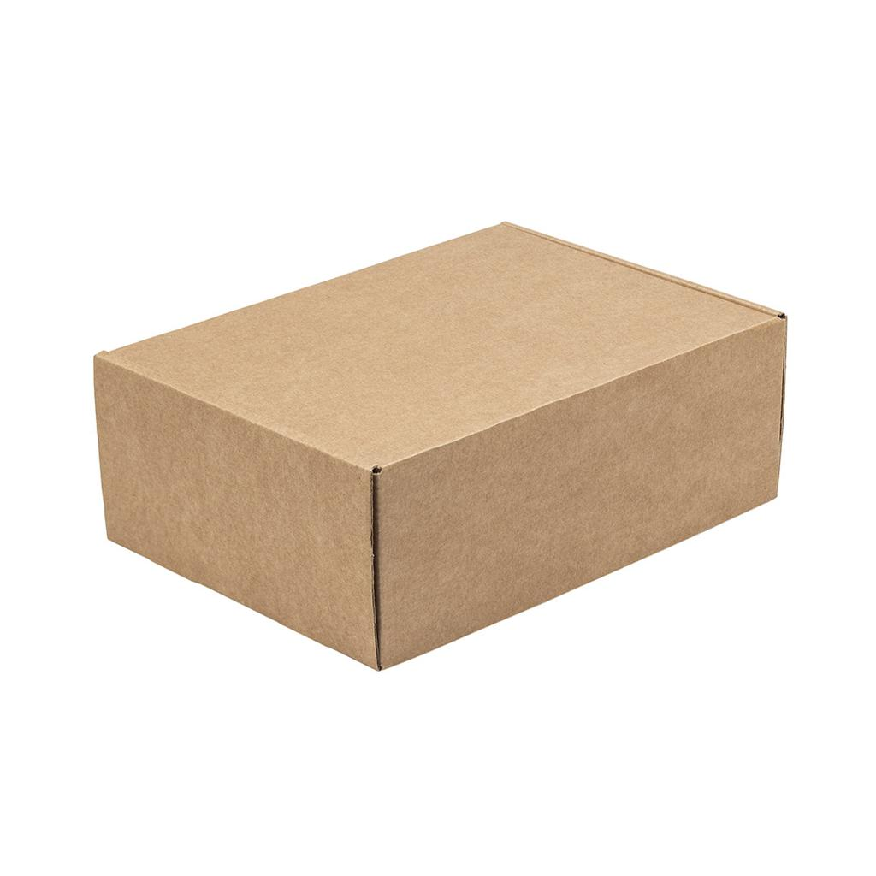
Architecture
Prismatic columns and structural elements use polygonal cross-sections.

Construction
Prismatic shapes help model beams, supports, and roof components.
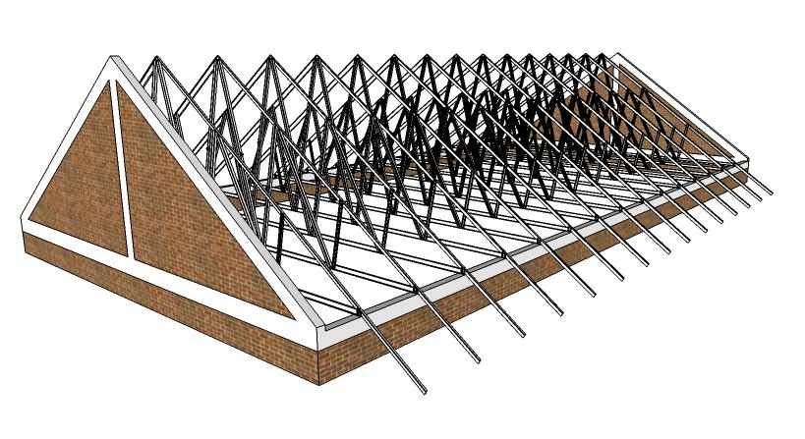
Optics
Glass prisms can refract and disperse light; optical prisms need not be right prisms.


Key points
# Source: AI Source: Provided by: [Data Path: Persons Table -> ID Column: 1, Name_En Column: Motasem Essam] -> From: [ChatGPT] on [7/25/2026]
- A prism has two congruent, parallel polygonal bases.
- Its lateral faces are parallelograms, or rectangles in a right prism.
- The base polygon determines the prism's name.
- An $n$-gonal prism has $n+2$ faces, $3n$ edges, and $2n$ vertices.
- The volume is $V=Bh$.
- For a right prism, the lateral surface area is $S_{L}=ph$, and the total surface area is $S_{T}=ph+2B$.
- Every convex prism satisfies Euler's formula, $V-E+F=2$.

Conclusion
# Source: AI Source: Provided by: [Data Path: Persons Table -> ID Column: 1, Name_En Column: Motasem Essam] -> From: [ChatGPT] on [7/25/2026]
Prisms are an important family of polyhedra characterized by two congruent, parallel polygonal bases. They can be classified by base shape, base regularity, and the orientation of their lateral edges. Their face, edge, and vertex counts follow simple general formulas, while their volume and surface area can be calculated from the base area, base perimeter, and height.

